

⧹

⧹

**Project Report on**

**Online Sweet Shop Management**

**Submitted For Partial Fulfil Towards the Degree Of**

**BACHELOR OF COMPUTER APPLICATION [BCA]**

**YEAR: 2023-2024**

**Submitted To:**

**M.K. INSTITUE OF COMPUTER STUDIES, BHARUCH**



**Submitted By:**

**Manish Rajput**

**Exam Seat No: 1818**

**Roll No. : 21B121**

**INTERNAL GUIDE:**

**Drashti Naik**

*Index*

|  |  |  |
| --- | --- | --- |
| *No.* | *Title* | *Page No* |
| *1* | *Project Profile* | *3* |
| *2* | *Project Introduction* | *4* |
| *3* | *Scope And Objective* | *5* |
| *4* | *Tools And Technologies* | *6* |
| *5* | *Table Design* | *7* |
| *6* | *DFD* | *9* |
| *7* | *System Module* | *15* |
| *8* | *Screenshots* | *16* |
| *9* | *Future Enhancement* | *25* |

1.0 Project Profile

|  |  |
| --- | --- |
| **Project Name** | Online Sweet Shop Management System |
| **Developed By :** | Manish Rajput 21B121 |
| **College Details :** | Name : M.K.Institute of computer studies  Address : Old NH-8,College Campus, Bharuch  Phone : 02642 225637  Email-id:[mkinstitute@gmail.com](mailto:mkinstitute@gmail.com)  Website : www.mkics.in |
| **Internal Guide :** | Drashti Naik |
| **Front End :** | Html,Bootstrap 5,Jquery,Css |
| **Back End :** | Mysql |
| **Server Side Scripting language:** | Php |

**2.0 Project Introduction**

The “Online Sweet Shop Management” has been developed to find online best, taste & trusted product in user city.

Our sweet shop understands that convenience is important, especially during the festive season. That's why offer online ordering services, allowing you to browse through extensive menu and place your order from the comfort of your home.

The application is reduce as much as possible to avoid errors while entering the data. No formal knowledge is needed for the user to use this system. Thus by this all it proves it is user-friendly.

2.1 Project Definition

Online Sweet Shop Management system with you can conveniently manage Sweet Shop business from one easy-to-use online platform.

3.0 Scope And Objective

3.1 Scope

Scope for admin

* Create Admin login
* View user details
* Update and delete any user details
* View all product
* Delete all products

Scope for Users

* User Registration use to create a account
* Login Username And Password user order the product
* View its own order
* Do User Payment Pay to order the product
  1. Objective
* Basic objective of this web application is to provide an online order from home.
* User can easily find product according its requirements.

4.Tools And Technologies

4.1 System Technologies

* + Html
  + Css
  + Javascript
  + Jquery 3.7.0
  + Bootstrap 5
  + Php 5.2.0
  + Angular.js

4.2 Software Requirements

* + Back End : MySql 8.0.31 , PhpMyAdmin 5.2.0, Apache 2.4.52,WampServer 3.2.6 - 64bit
  + Operating System : Windows 10 And windows 11
  + Browser Supports : Google Chrome, Microsoft Edge

*5.Table Design*

**Table : dbitems**

|  |  |  |  |
| --- | --- | --- | --- |
| ***Fieldname*** | ***Datatype*** | ***Fieldsize*** | ***Description*** |
| Id | Int | 10 | Primary key |
| PName | varchar | 50 | not null |
| Pprice | int | 10 | Not null |
| Pimage | varchar | 200 | Not null |
| Pcategory | varchar | 100 | not null |

**Table : Register_master**

|  |  |  |  |
| --- | --- | --- | --- |
| **Fieldname** | **Datatype** | **Fieldsize** | **Description** |
| Id | Int | 10 | Primary key |
| Name | varchar | 50 | not null |
| Password | varchar | 50 | Not null |
| Email | varchar | 50 | Not null |
| Gender | varchar | 10 | not null |
| Phone_no. | int | 15 | Not null |
| Address | varchar | 50 | Not null |

**Table : payment_info**

|  |  |  |  |
| --- | --- | --- | --- |
| **Fieldname** | **Datatype** | **Fieldsize** | **Description** |
| User_Id | Int | 10 | Primary key |
| FullName | varchar | 15 | not null |
| Email | varchar | 20 | Not null |
| Address | varchar | 50 | Not null |
| City | varchar | 15 | not null |
| State | int | 15 | Not null |
| Holder_name | varchar | 20 | Not null |
| Card_Number | int | 20 | Not null |
| Exp_month | varchar | 15 | Not null |
| Exp_Year | int | 5 | Not null |
| CVV | int | 5 | Not null |

6. DFD(Data Flow Diagram)

Definition

Data flow is a network diagram illustrating a computerized system, manual or a combination of both, and representation in the form of a set of structured system components that are interconnected in accordance with the rules play. Advantages of DFD is possible to describe the system from the highest level and then them into a lower level (decomposition), whereas the lack of the DFD does not indicate the process is looping, decision-making process and the process of calculation.

Data Flow Diagram Symbols

|  |
| --- |
| * Process – perform some action on   **Process** data, such as creates, modifies , stores ,  delete etc. Can be manual or supported  by computer   * Data store – information that is kept   **Data Flow** And Accessed. May be in paper file  folder or a database.   * External entity – is the origin or   **External** destination of data. Entities are  **Entity** external to the system.   * Data flow – the flow of data into or   **Data Flow** out of a process , datastore or entity. |

Context Level DFD

SWEET SHOP MANAGEMENT SYSTEM

login_detail login_details

product_details registration_detail

ADMIN

USER

order_details validation_details

validation_message product_details

payment_details order_details

payment_data

1st LEVEL DFD FOR ADMIN

Login_detail login_detail

1.0

Login

Validation_msg admin_master

verification_detail

2.0

ManageProduct

p

Product_detail p_detail product_master

3.0

Order

ADMIN

order_detail ord_detail order_master

4.0

Payment

Payment_data payment_detail

Payment_master

Database

5.0

Generate Report

Reports

Reports

1st LEVEL DFD FOR USER

1.0

**registration**

registration_ detail registration _details

user_master

login_detail

2.0

Login

user

login_detail validation_detail

verification_msg

Product_master

3.0

Product search

Product_detail product_detail

Order_master

4.0

Order process

ppo

order_detail order_detail

5.0

Payment

payment_detail payment_master

payment_detail

2nd LEVEL DFD FOR PROCESS NO.2 OF ADMIN

2.1

Add new product

Add_new_product_details New _product_details

2.2

Update product

Update_product_details Update_product_details

Product_master

Admin

2.3

Delete product

Delete_products

Delete_product_detail

2.4

View product

Product_view Product_view

2nd LEVEL DFD FOR PROCESS NO.5 OF ADMIN

User_reports

5.1

User

Report

User_details User_master

Admin

5.2

Product Report

Product_details Product_master Product_reports

7. System Module

There are two modules:

1)Admin

2)User

Functionalities Admin Module

* + login.
  + View users, remove them and update them.
  + Add update and delete product.
  + View payment.

User Module

* + Login.
  + Book more than one products according its requirements.
  + View order product and cancel product.
  + View its own profile and update profile.

8. Screenshots

User Side:

**Login page**: both admin and user can login here

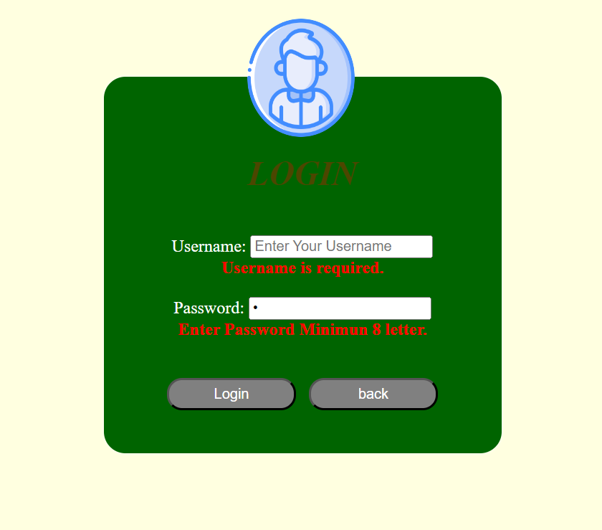

**User Registration:** user can register here.

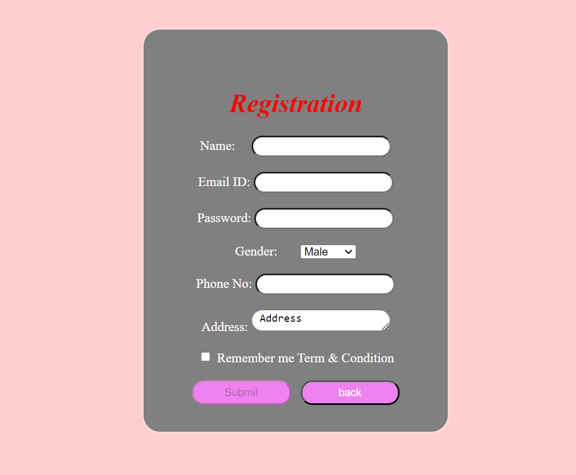

**User Home Page :** user can see services

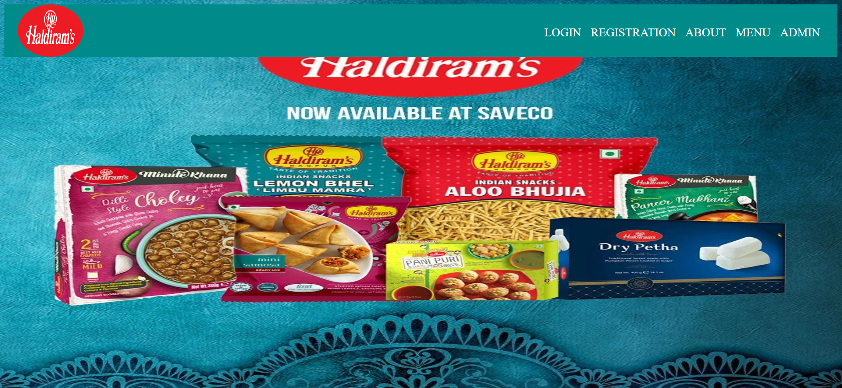

**User About Page :** user can see About page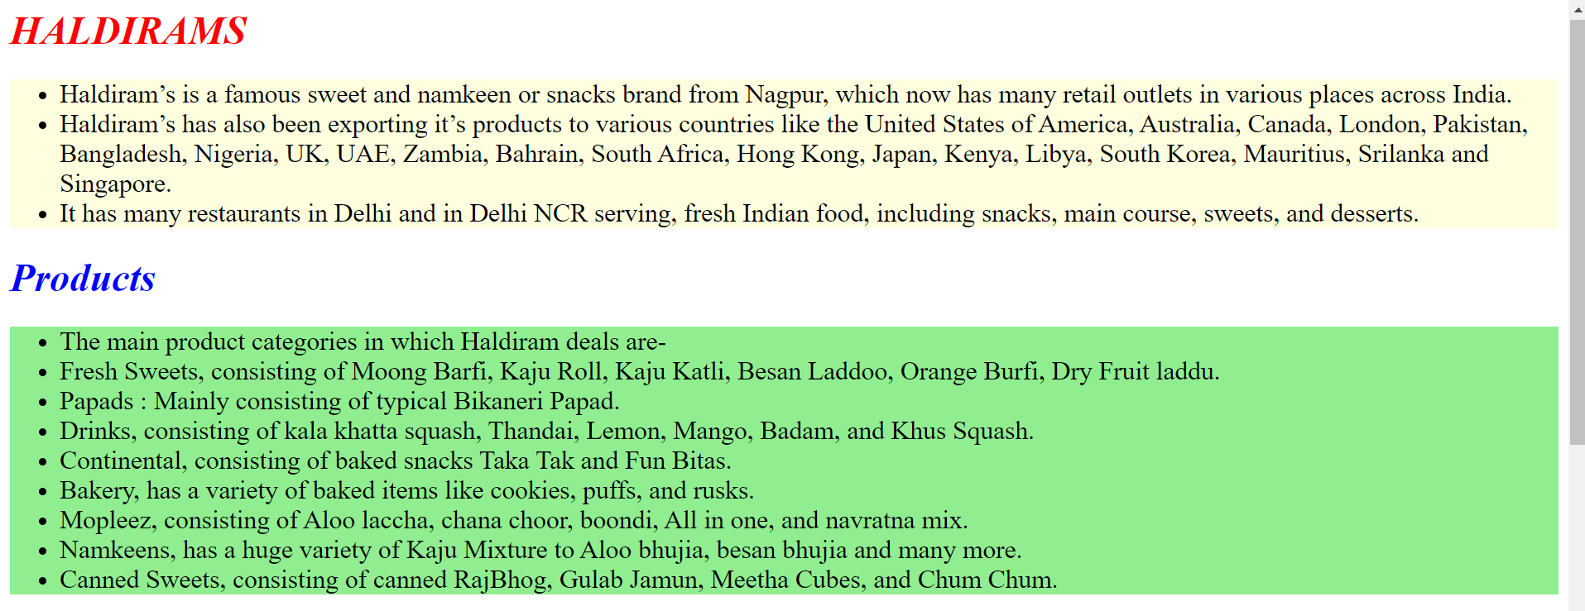

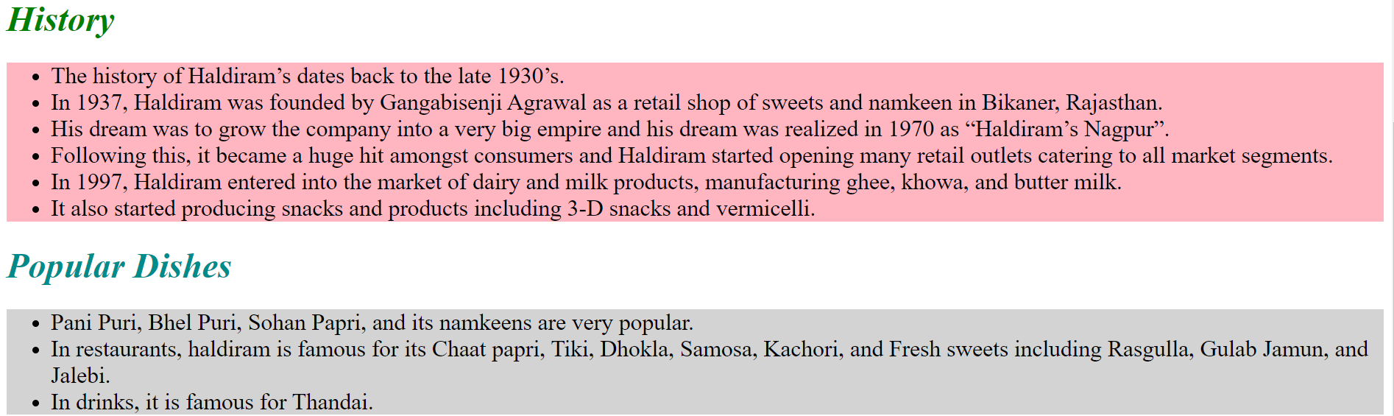

**User Menu Page :** user can see Menu Page

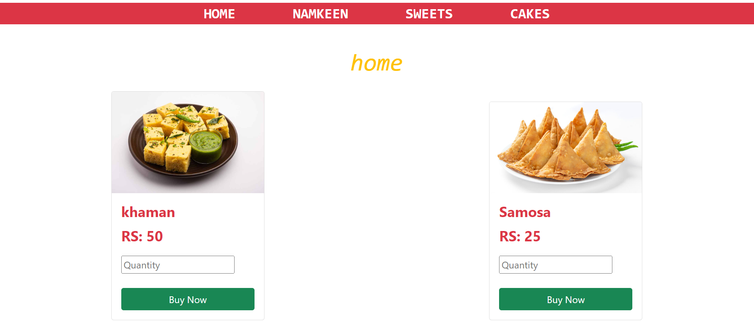

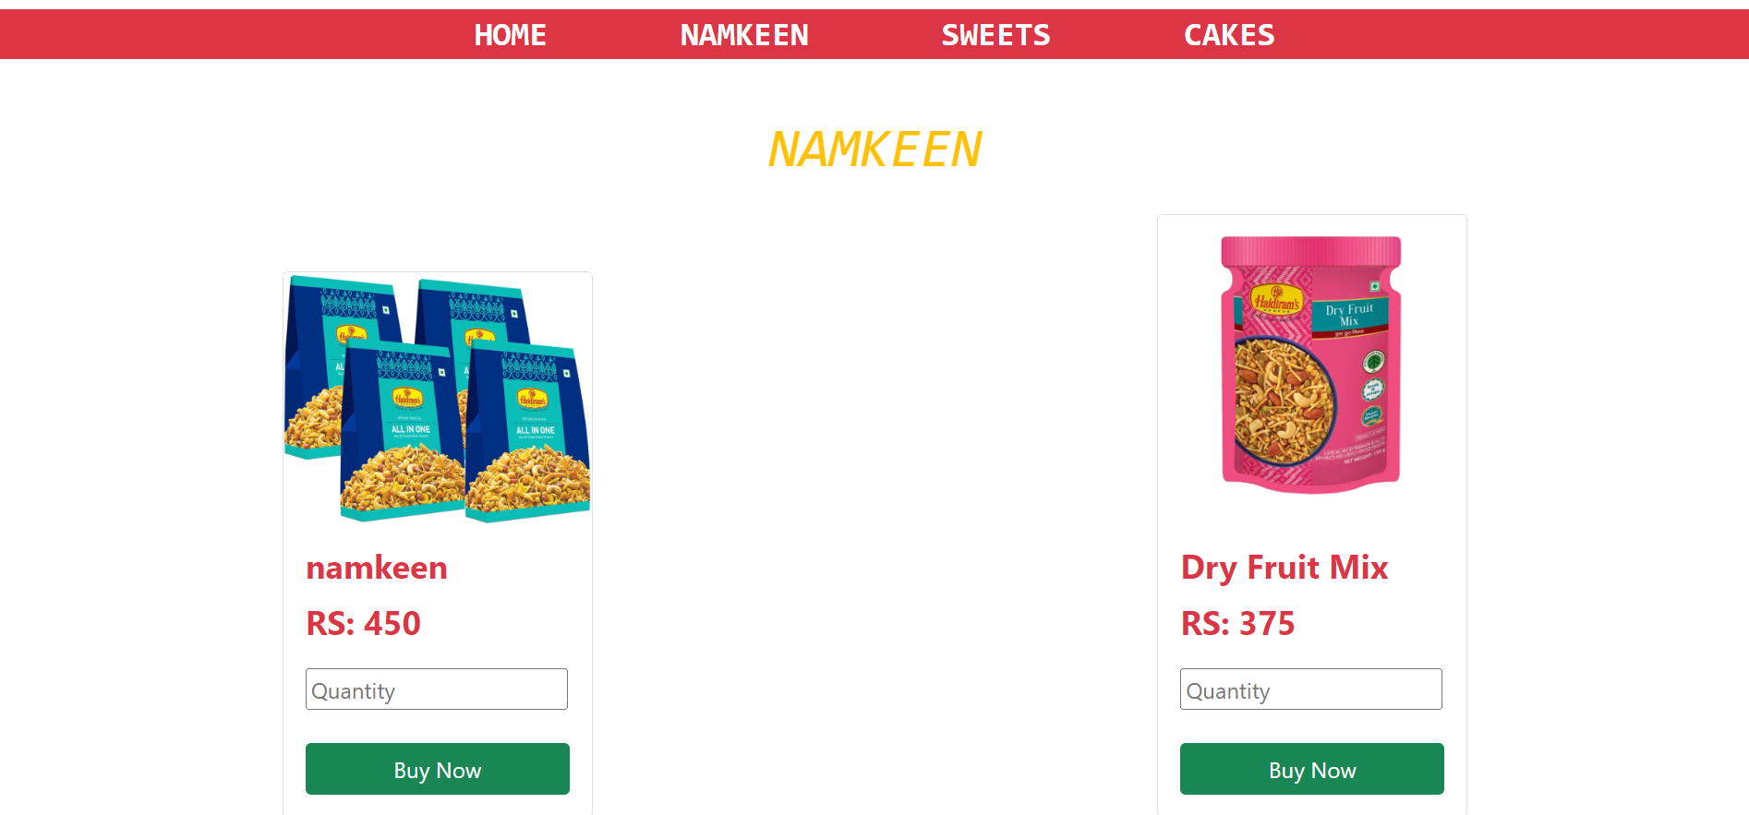

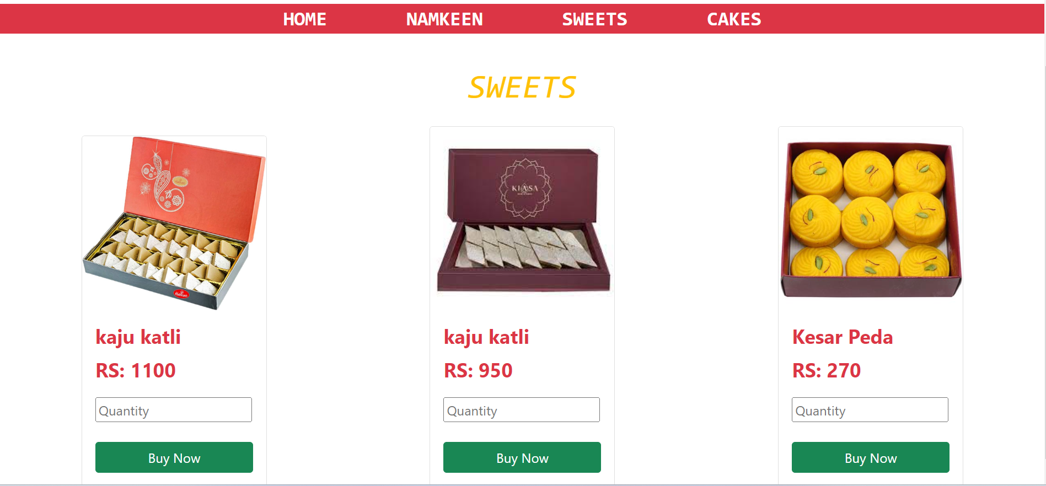

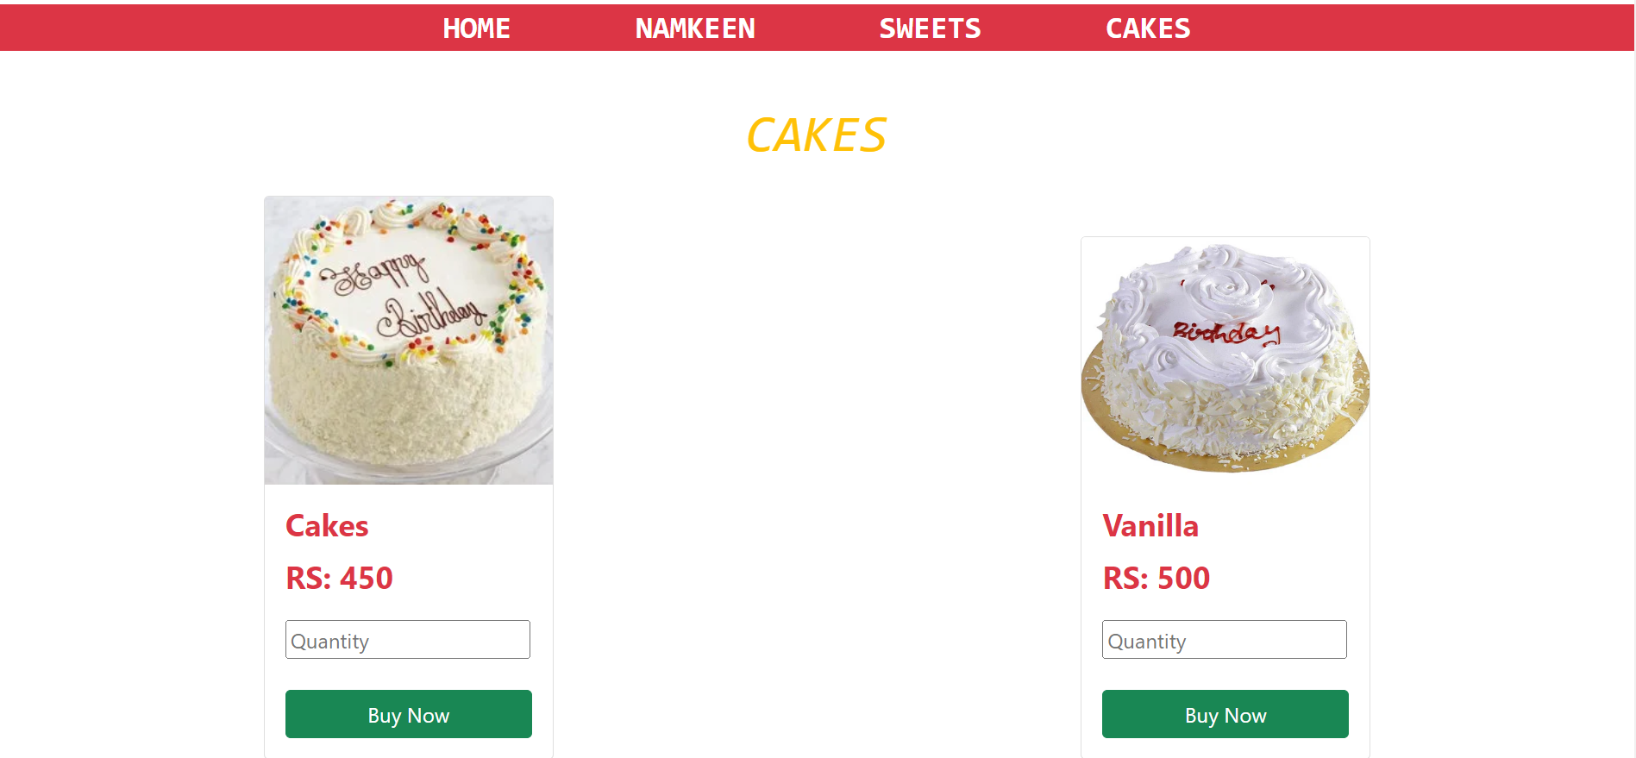

**User Menu Page :** user can Buy the products.

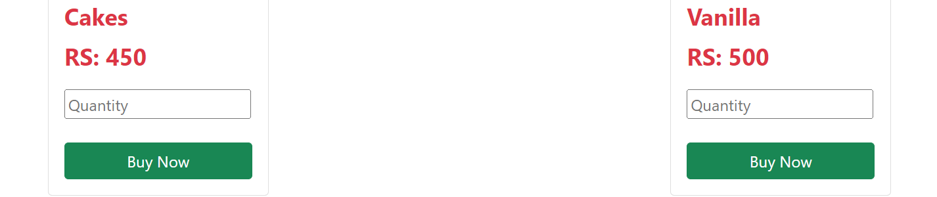

Admin Module:

**Admin Home Page:** This is admin home page.

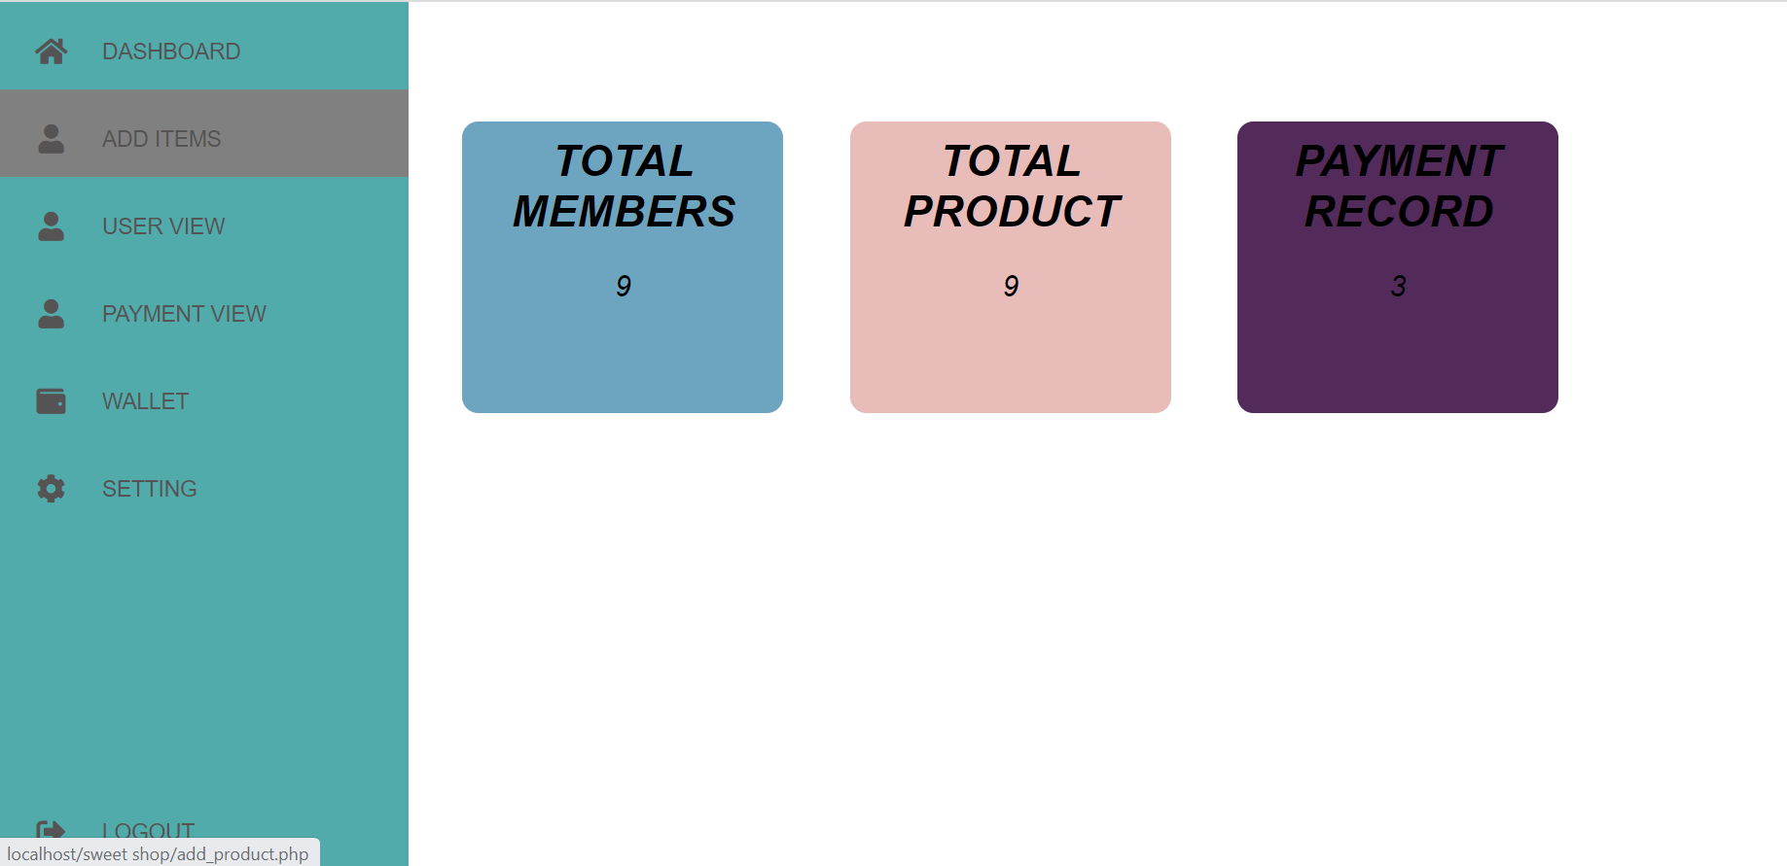

**Manage User:** admin can update and delete users.

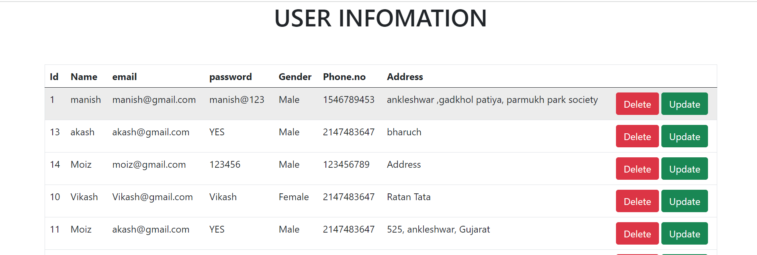

**Update User:** this user updation form.

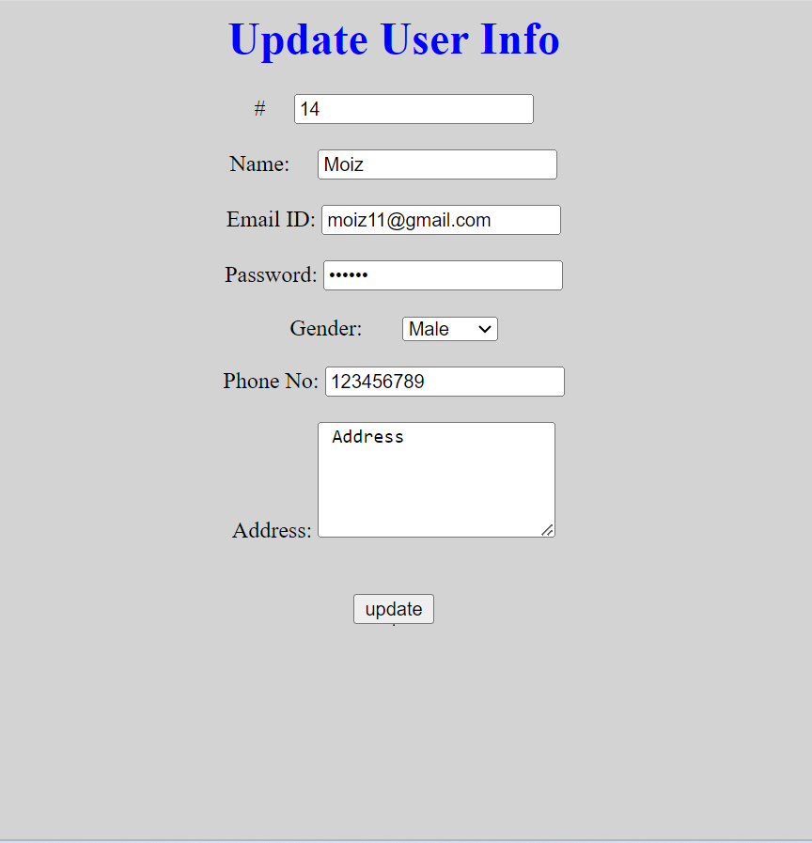

**Delete User:** admin can delete user.

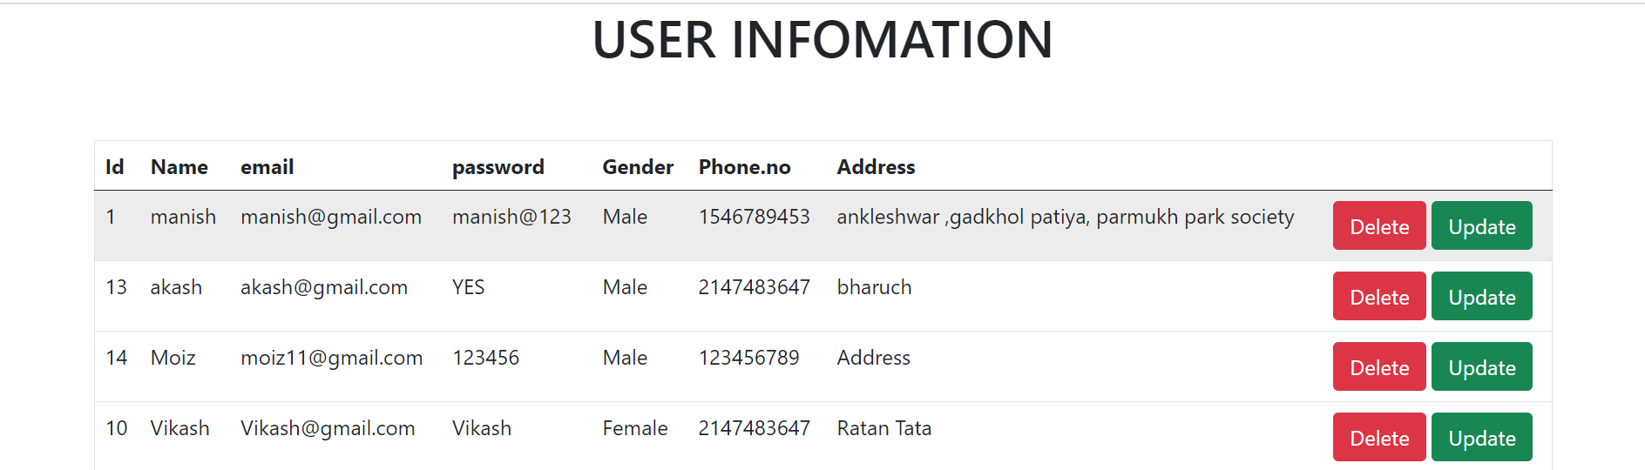

**Manage Product:** admin can insert , update and delete products

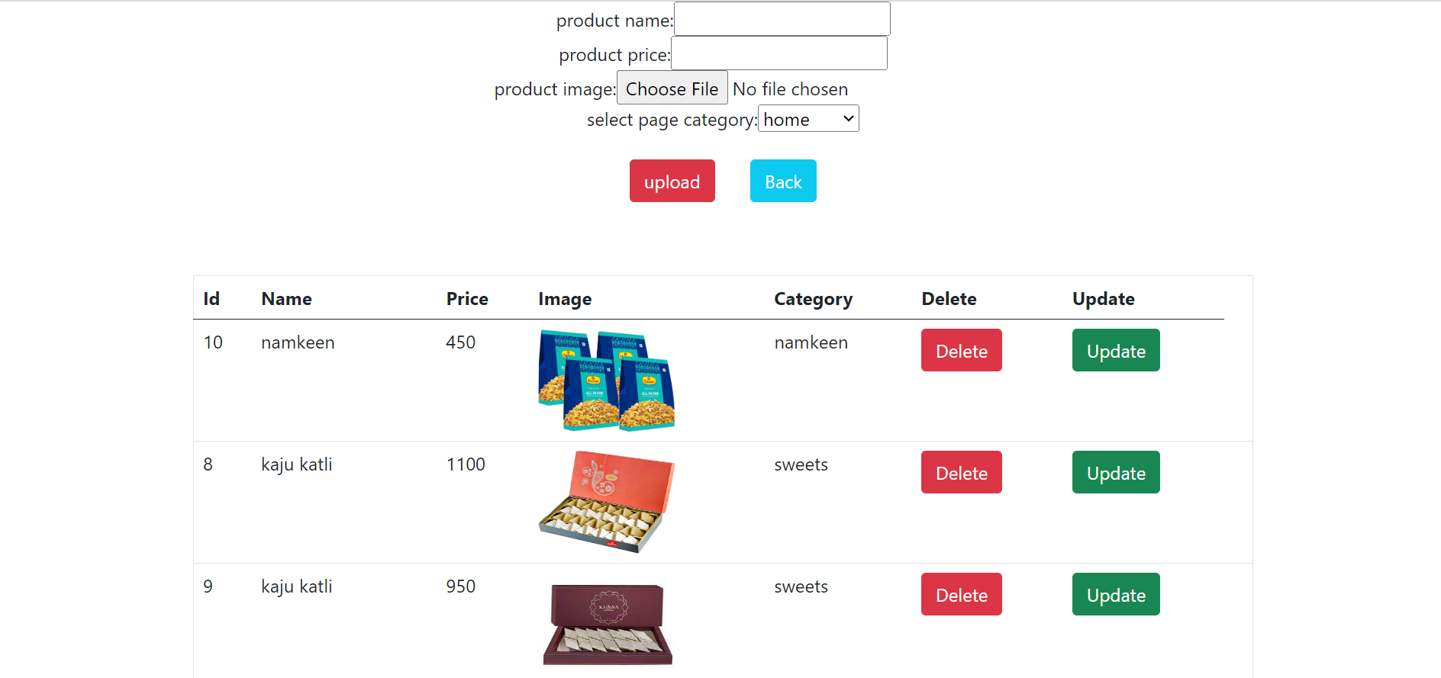.

**Update Product:** this form updation product.

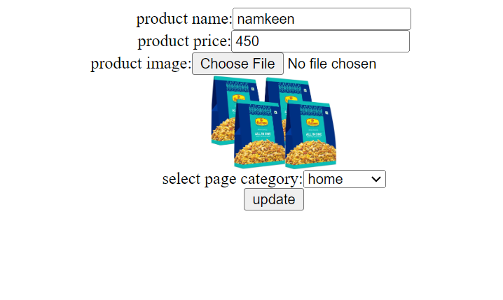

**Payment Reports:** admin can view payment records.

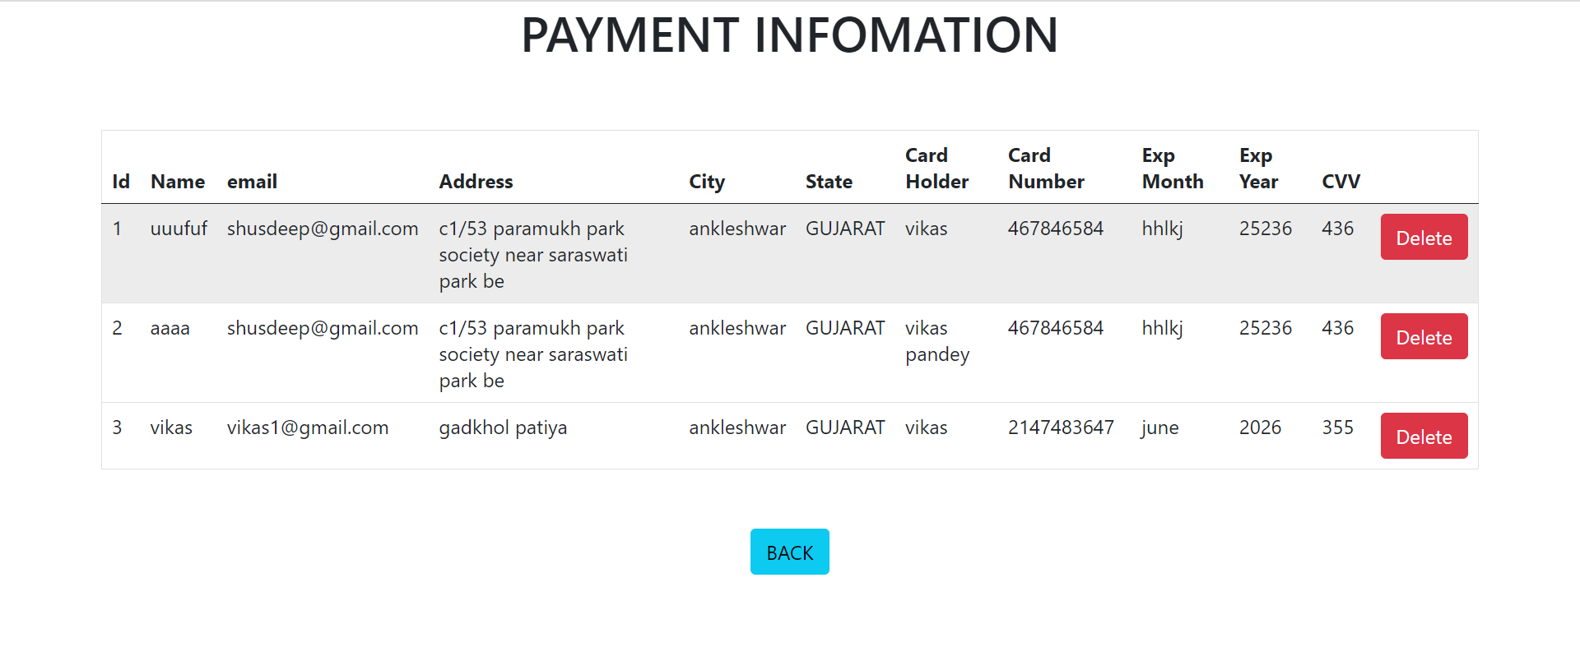

9. Future Enhancement

In Future This Web Application will be serving as a complete service to user that include following feature.

* + In Future New Type of Products will be available.
  + User will be able to change password Using Otp.
  + User will get a payment recipe.